m[Guided Prompt AI] Site Plan

[Esther Scott-Richards]

WDD 130

Overview

Purpose
[To empower users with meaningful, spirit-guided answers by transforming their prompts, phrases, or quotes into personalized scripture and General Conference insights. Through keyword extraction and intelligent matching, the system connects users to relevant verses and talks, then uses AI to provide simplified explanations and reflections that relate gospel truths to modern life, current events, and personal challenges. It also suggests additional scriptures for deeper study, helping users grow in faith and understanding.

Audience
[Worldwide]

Branding

Website Logo


Style Guide

Color Palette
Primary | Secondary | Accent 1 | Accent 2
#6e594c | #e3cf98 | #284982 | #ebd5ae

Typography

Heading Font: [Alata]

Paragraph Font: [ABeeZee]

Navigation
Home Page2 Page3

Content

[i want this to have a user put in a prompt, phrase or quote and then go into a database with scriptures and conference talks and give user related key words from the prompt, as well as AI generated txt of how the scripture stories may be related to our days and what’s going on in the news and around us in our life’s and as well as other references of scriptures to look up for more help.
Want:
-text box for prompt to be entered
-text box for date reference of talk but users don’t have to always put a date each page has pictures
Maybe have background as scenic view?

Page 1:((“Search”)home page( with prompt boxes) and option to make a login, you can see past his
Page 2:(“Library”) scripture reference page, it will have links to lds.org, bible.com, byu speeches the art will be of unique Art pictures of jesus with others(not just the basic pictures) and photos of the sctiptures(Bible, BOM, D&C, PoGP)
Page: 3: (“Extras” page) will have an option to create a notebook and save it to account,
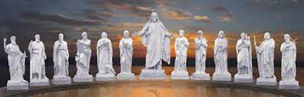

Don’t need at the moment:
- Database will be created later next year(don’t worry about it.)
More details:
You can see past look up history.
You have save and find past notebook history.

Some designs I like:
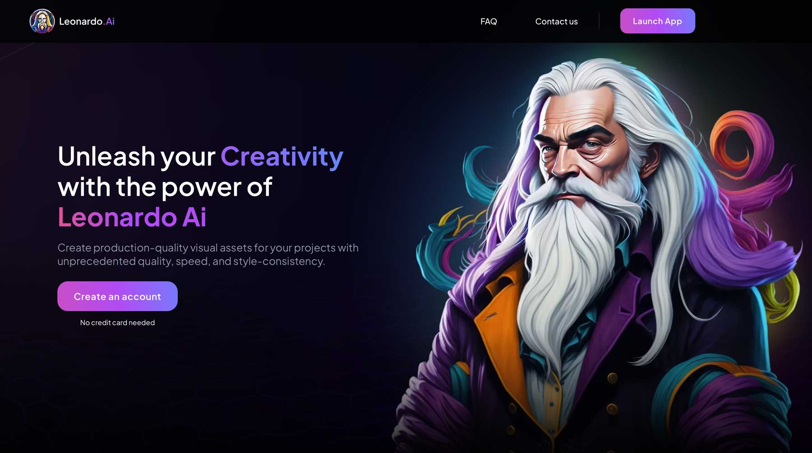

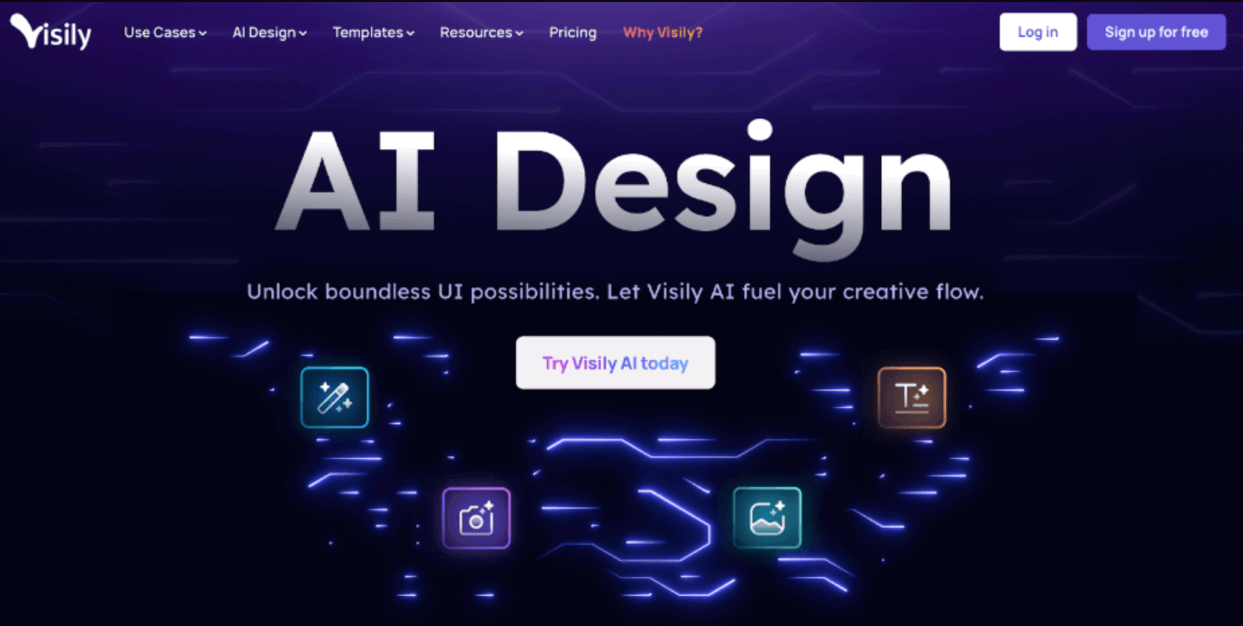
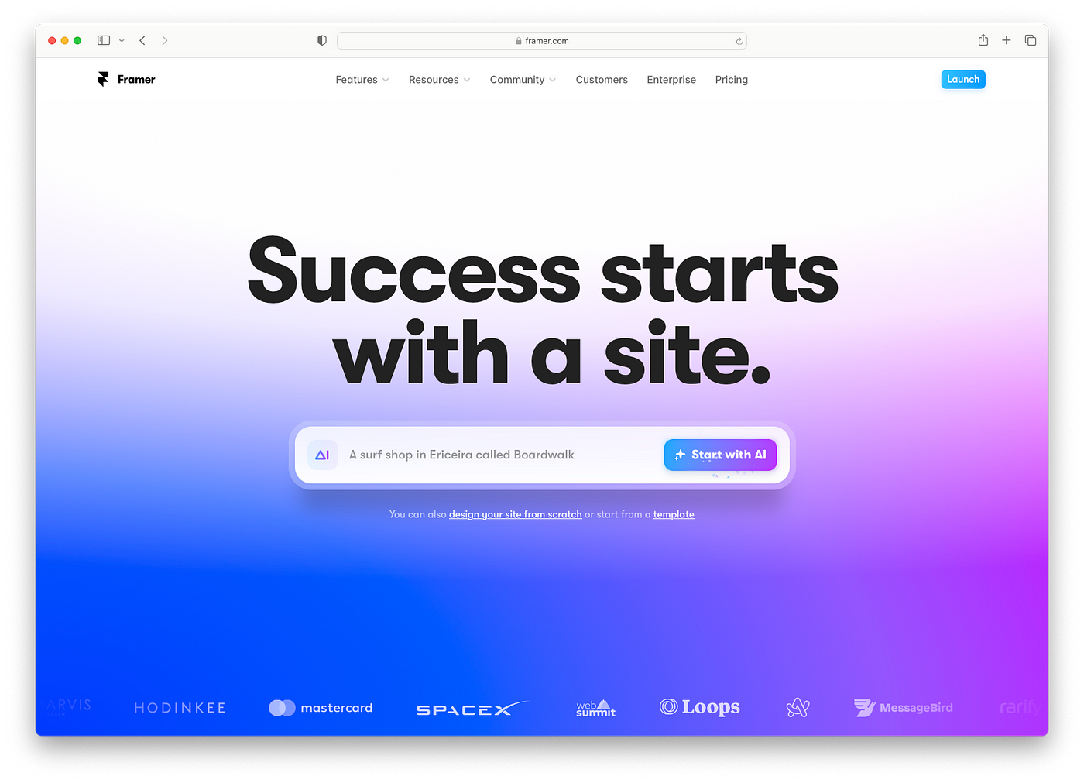
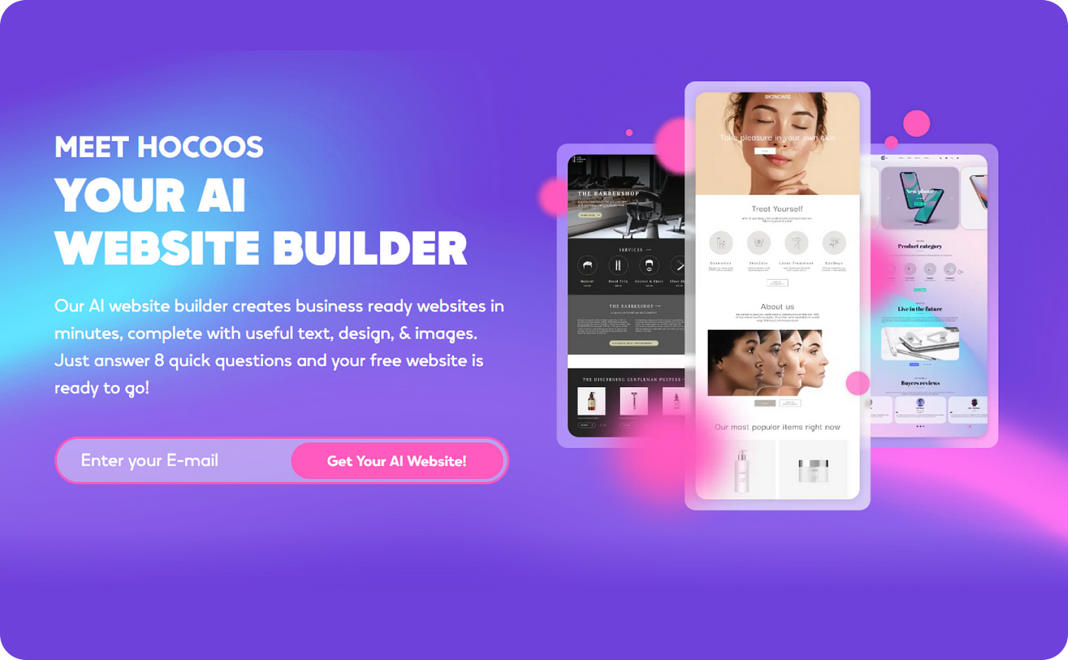

Wireframes

Home

